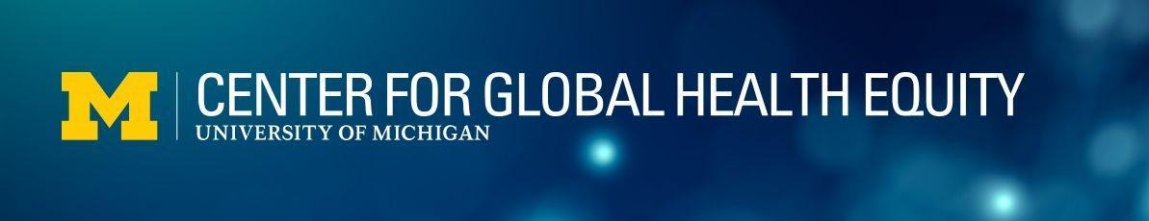

SEED GRANT APPLICATION
Background
The Center for Global Health Equity (CGHE) brings together faculty from across all three campuses of the University of Michigan (U-M), leveraging expertise from multiple disciplines in pursuit of novel solutions to global health challenges that can positively impact communities in low- and middle-income (LMIC) settings. Based on potential for impact, institutional strengths, and perceived needs, the Center has identified four thematic priorities to guide collaborations and funding programs.
- Strengthening systems to improve health and health equity, including creative approaches with the private sector (human resource development, collaborative care models, supply-chain, and access)
- Addressing and informing policy on the social and environmental determinants of health (climate change, food security, education, health economics, and economic development)
- Developing technical solutions for health equity (artificial intelligence and data science approaches, telehealth tools, and systems)
- Empowering women as effectors of health for themselves, their families, and their communities
Funding Purposes and Requirements

CGHE Seed Grants support exploratory projects that catalyze novel ideas and collaborations and build a case for larger-scale or more expansive projects that will help people live healthier and longer lives. This grant program supports co-designed projects that will be implemented with a global partner. Proposals without a strong collaborative focus with partners in LMICs are unlikely to be successful.

Preference will be given to projects that build an evidence base for impact, design and test solutions, or pilot interventions. Other examples of funded projects may include—but are not limited to—exploring local needs, defining scope of work, validating feasibility of activities, and testing initial ideas.

Grant amount supported: up to $35,000
Project Duration: up to 12 months

Proposals must meet the following criteria:
- Focus on needs or problems identified by collaborators within LMIC settings.
- Align with at least one of the four thematic priorities of the Center.
- Be co-designed and implemented with a global collaborator(s).
- Demonstrate a clearly articulated ‘line of sight’ to impact health for those living in LMICs (i.e., if implemented, how could this project contribute to solutions or changes that could ultimately cause people to live longer or healthier lives?).
- Advance multidisciplinary collaboration by engaging at least 3 U-M schools/colleges/units within the project team.
- Include a comprehensive budget that addresses the needs of all collaborators to maximize involvement.
- Confirm that all U-M faculty on the project are Center members or agree to become members (see application). Non-UM project team members are encouraged to affiliate with the CGHE as Associate members, but this is not required.

Proposal Submission and Review Process
Applicants are encouraged to consult with CGHE leadership, project managers, and/or relevant Challenge Groups as proposals are being developed to seek feedback on ideas, identify potential collaborators, and address any questions about the grant criteria.

Applications must include:
- Seed Grant application form (please see page 3 of this document)
- Budget request and budget justification
Please submit application materials to Kelly Espinoza (kaespino@med.umich.edu). Application decisions will be provided within six to eight weeks of submission.

Reporting and Communication
Project leaders will ensure that the following reporting and communication activities are completed:

- Provide periodic progress updates to the CGHE through project kick off, midpoint and endpoint meetings.
- Submit a final report detailing activities completed, results, lessons learned, and next steps.
- Liaise with the CGHE communications team to create materials and articles on the implementation and impact of the project.
- Connect with a relevant Challenge Group or other community of practice at the CGHE to share project updates and results.

SEED GRANT APPLICATION FORM
(No more than 5 pages are expected for Questions 4-12)

- What is the title of your Seed Grant Project?

- What is the amount requested and duration of the project:

Amount Requested:
Duration:

- Please provide the following information for all members of the U-M and Global Partner joint project team:
Name:
Title:
Organization:
Primary U-M Affiliation (School, College, Department as applicable, please note for the purposes of this application, we do not consider dry appointments):
Project Role (Describe the tasks that the project team member would work on)
- Please describe how the team (U-M Members and Global Partners) worked together to identify the problem/need and co-design the project. How were ideas shared and decisions made about the design of the proposal?

- What health equity problem(s) does this proposal address? Address any aspects of the problem that demonstrate a particularly urgent or critical need. Please incorporate descriptive statistics and supporting literature.

- How does this project advance one or more of the Center’s thematic priorities? In terms of building community, which CGHE Challenge group or other community of practice is best aligned with the project?

- What are the overall objectives of this proposal?

- What are the main activities of the proposed project?

- What do you want to accomplish with this project? What are the expected results or outcomes?
- Describe how this project would contribute to further work that would ultimately have health equity impacts (i.e. lead people to live healthier or longer lives in LMIC contexts).

- Does this proposal connect to or build on other projects or grants? If yes, please describe how this proposal is connected to the existing project and explain what new activities will be pursued with CGHE funding. How will expected outputs/outcomes of the existing project be different as a result of this CGHE funding?

- Please include a budget and budget justification. Utilizing these templates will facilitate application review and ensure that key expenses are included.
Budget request and budget justification

The grant clock will start from the time when the project kicks off. The project should start within 6 months of the notice of award.

